**Senior Order Week is here at JHR!**

Your student will receive a packet of graduation information at school Thursday Oct. 28th. Please make sure that this information is brought home for your inspection. You may order online this week or with us in school on the order day below:

**Order Day:**

**Wednesday Nov. 3rd**

**During Lunches**

If ordering in school, please have order forms filled out completely. A $75 deposit or payment in full is needed to place your order. Extra order packets are in the High School Office.

Click on the picture below to view the video and and online order information:

[****](https://view.vidreach.io/viewer/reach/ea528bb5-6689-4dc2-8dd0-afcd43ca5f49/61ea6b4c-d128-41fd-8f31-3478a00b8b93/c782cbcd-ad76-49ff-b95d-3e7573a5b643?pk_campaign=61ea6b4c-d128-41fd-8f31-3478a00b8b93)

**Class of 2023!!,**

**Don't miss out!!**

Your student will receive a Class Ring Packet on Thursday Oct. 28th. Design your Class Jewelry, print your order and bring it to us on your in school order day:

**Wednesday Nov. 3rd. During Lunches:**

Order on this day or online by the Nov. 3rd deadline and receive a special gift from your Jostens team - A set of ***CLEER EAR BUDS***!!

Click on the picture below to view the video and and online order information:

[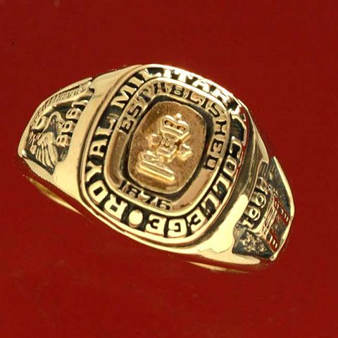](https://view.vidreach.io/viewer/reach/ea528bb5-6689-4dc2-8dd0-afcd43ca5f49/6fd42593-bcdf-40ac-b863-ab2ca7373c59/4d625722-6fbf-4c80-9245-c5795ed45ba9?pk_campaign=6fd42593-bcdf-40ac-b863-ab2ca7373c59)