|  |  |  |  |
| --- | --- | --- | --- |
| **Requirements** | **Date(s)** | **Events/Activities** | **Documentation** |
| Annual Meeting to inform parents that your school is in a Title I Program | **August 23, 2018** | System-Wide Open House  Back to School Night | * *Wahl-Coates School of the Arts Title 1 Parent Engagement Policy* * Sign in sheet from System-Wide Open House * Agenda and sign-in sheet from Back to School Night |
| Explain how parents are involved in supporting Parent Engagement Policy and Comprehensive School Plans | **Twice a Month (TBD)**  **August 23, 2018**  **September 27, 2018**  **Monthly (TBD)** | SIT meetings  Open House  Back to School Night  Captain’s Crew Luncheon with students, parents and community member  Parent Workshops | * SIT meeting agendas, minutes and sign-in sheets * Invitations, agenda, sign-in sheets to all parent engagement activities |
| School’s responsibility to provide a high-quality curriculum in a supportive and effective learning environment. How do you inform parents about the PCS School-Parent Compact | **September 27, 2018** | Back to School Night | * Completed Wahl-Coates- Student/Parent/Teacher /Administrator Contracts * Agenda and sign-in sheet from Back to School Night * Parent Handbook |
| Communication between teacher and parents on an on-going basis about child’s achievement, progress reports or opportunities to volunteer. Explain your school process. | **Weekly**  **Daily**  **On-going** | Purple Communication Folders  Homework Folders (K-2)  Student Planners (3-5)  Alert Now System  Facebook  Email  Class Dojo (Grades 2-5) | * Weekly newsletters and informal and formal progress reports sent home by teachers * Notices sent by teachers and administration about up-coming events and school activities * Alert Now Log * Copies of emails |
| Parent engagement training that support parents in helping their child at home  List parent workshops | **September 27, 2018**  **November 2, 2018**  **November 15, 2018**  **January 17, 2019**  **Monthly** | Back to School Night  RtA Luncheon  Science Fair Parent Workshop  EOG Night/Reading Night  Captain’s Crew Luncheons | * Invitations, agendas, hand outs and sign-in sheets |
| Information related to school and parent programs  How does the school present information to parents in a language that they understand? | **On-going**  **On-going**  **Monthly** | Purple Communication Folders  Student Planners  Student Handbooks  Parents Workshops  Home-School Connection | * Weekly newsletters and informal and informal progress reports sent home by teachers * Notices sent by teachers and administration about up-coming events and school activities * Invitations sent home in English and Spanish indicating translators will be provided * Examples of newsletters provided in English and Spanish |
| **Parent Communication:**  Explain how the schools enhance the home-school relationship and keeping them informed about school activities. | **Weekly**  **Daily**  **Monthly**  **On-going** | Purple Communication Folders  Homework Folders (K-2)  Student Planners (3-5)  Home-School Connection  Alert Now System  Emails, Facebook  Class Dojo (Grades 2-5) | * Weekly newsletters and informal and informal progress reports sent home by teachers. * Notices sent by teachers and administration about up-coming events and school activities * Examples of Home-School Connection Newsletters * Alert Now Log * Flyers, media, and photographs |



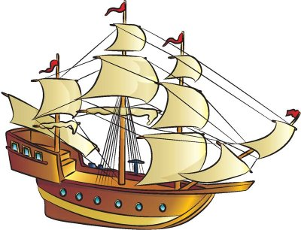

Wahl-Coates School

of the Arts

Parent Engagement Plan